Task 1 - Install DNS server role
Steps
- Open Server Manager
- Click Manage
- Add roles and features
- Select role-based of feature-based installation
- Choose your server
- Check DNS server
- Click Add features
- Install
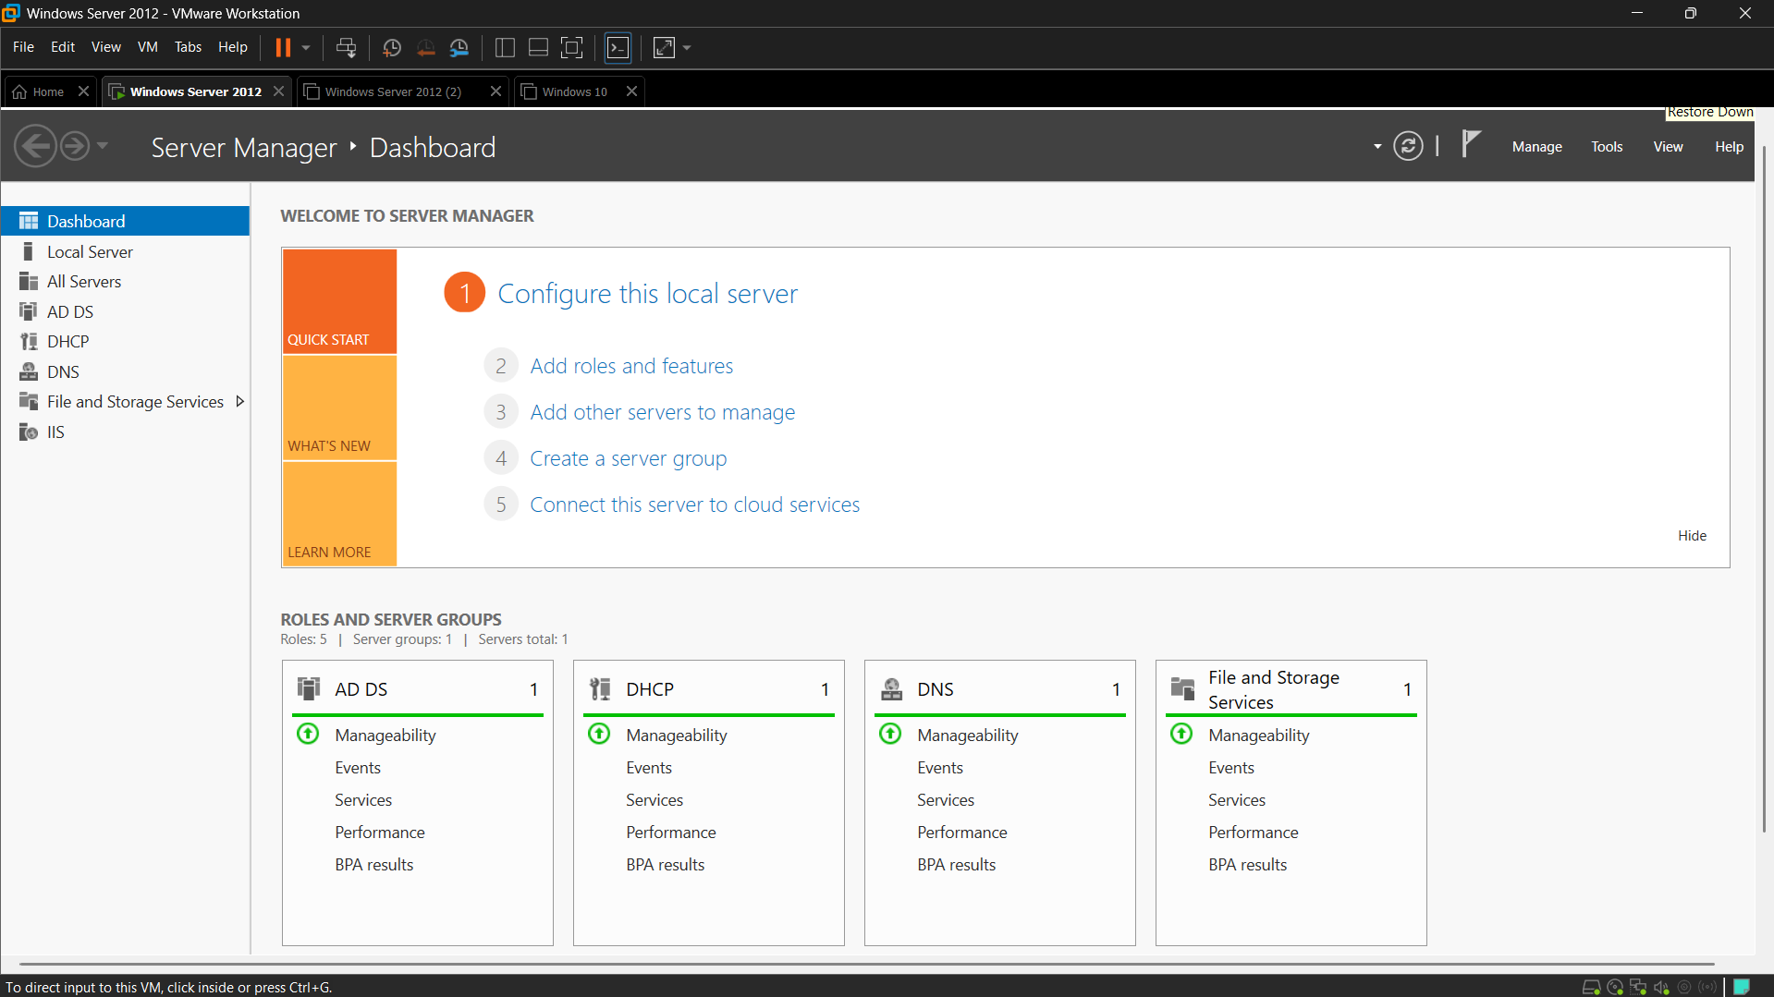

Task 2 - Create Forward Lookup zone
Steps
- Open Tools
- DNS
- Expand your server name
- Right-click Forward Lookup Zones
- Select New Zone
- Choose Primary Zone
- Zone Name: foodies.local
- Finish the wizard
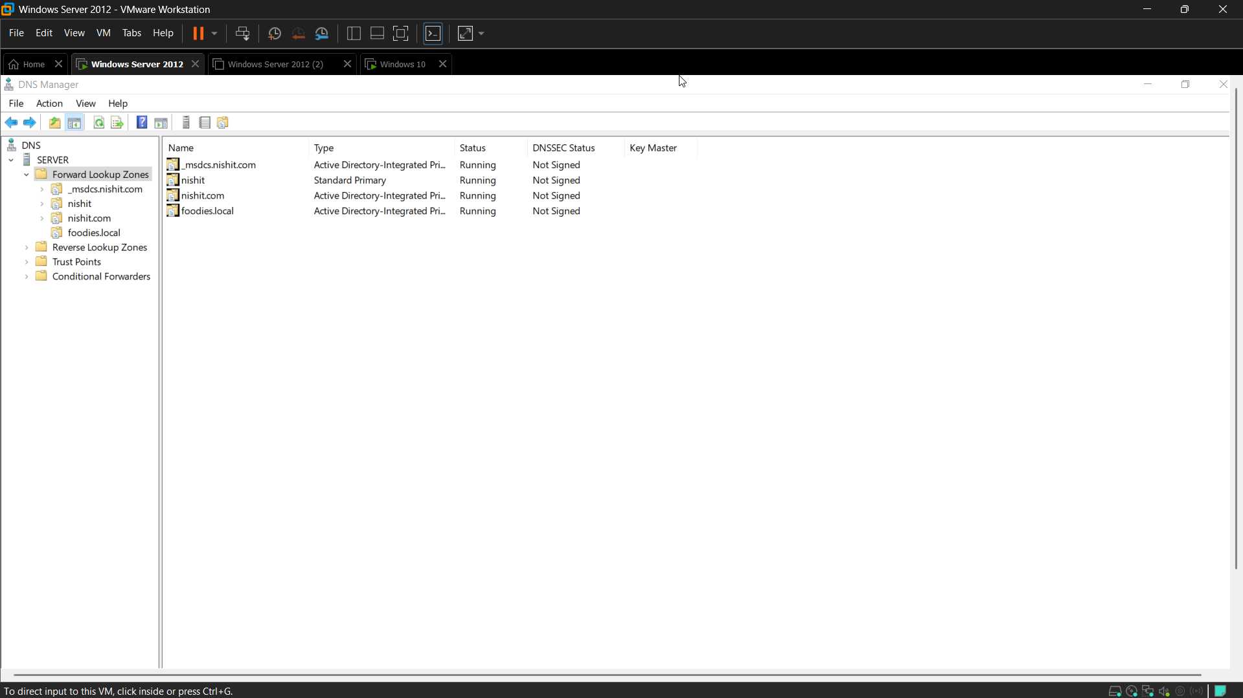

Create A Record
- Right-click foodies.local
- Select new host (A or AAAA)
- Name: zomato
- Ip address:192.168.1.50
- Click add host
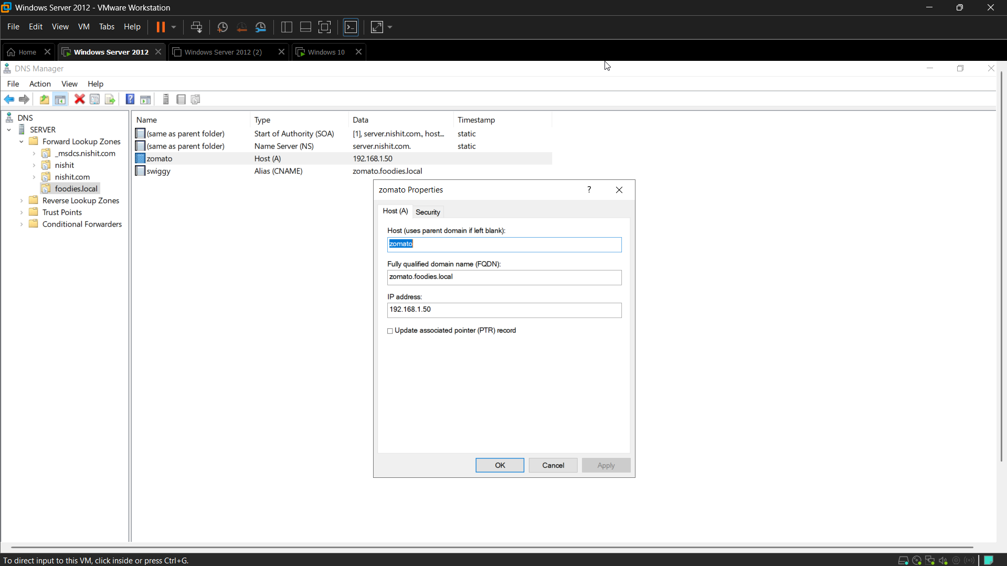

Task 3 - Create CNAME Record
Steps
- Right-click foodies.local
- Select New Alias (CNAME)
- Alias name: swiggy
- Fully Qualified Domain Name: zomato.foodies.local
- Ok
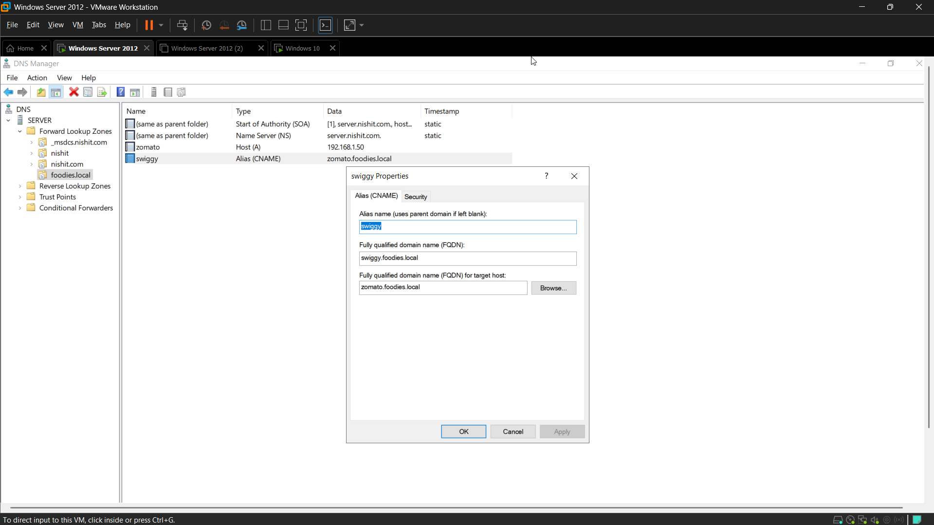

Task 4 - Test Using nslookup
Steps
- Open Command Prompt on client machine:
  - nslookup zomato.foodies.local
- Now test:
  - nslookup swiggy.foodies.local
- Expected Output:
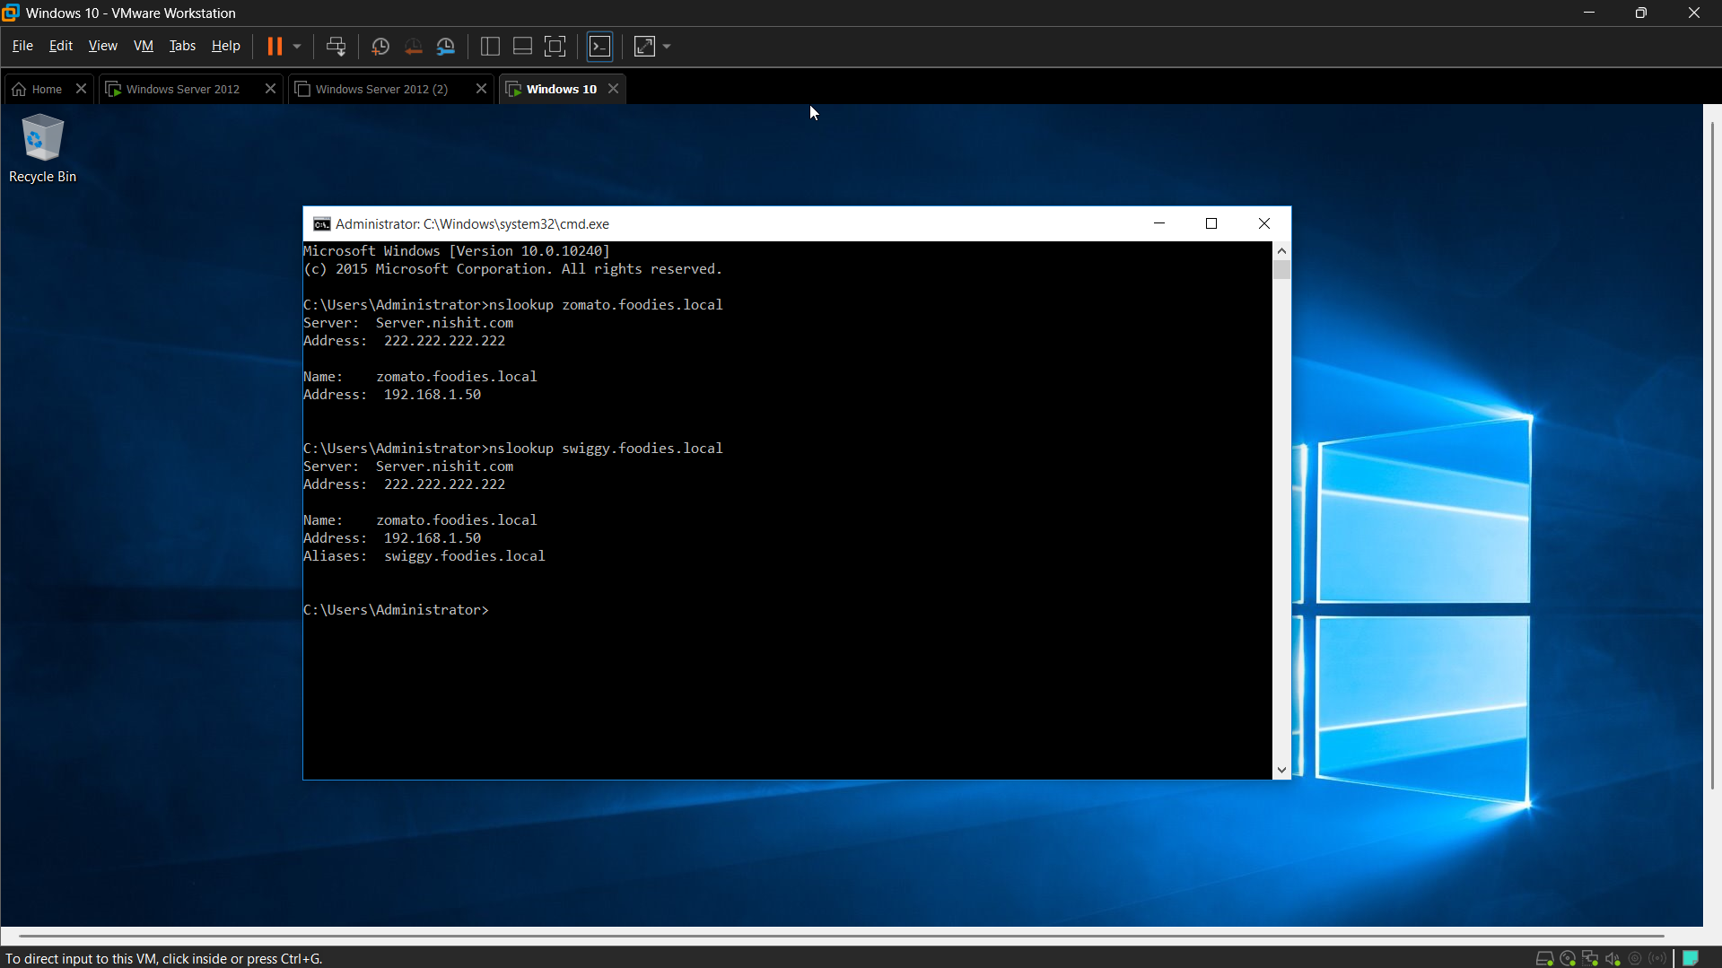

Explanation
DNS resolves domain names into IP addresses. The A record maps zomato.foodies.local directly to 192.168.1.50. The CNAME record creates an alias where swiggy.foodies.local points to zomato.foodies.local. When DNS resolves swiggy.foodies.local, it first follows the alias and then returns the IP address associated with zomato.foodies.local.

